# Test Plan

## Story – Basic Result Reporting (Ryan Reams)

## Fields

* **Dropdown**
  + Populated list of characters between 3 and 20 characters in length, or users who have successfully completed the results.
* **Table** 
  + A Populated result table for the user that was selected, containing 4 columns, that include Item (between 3 and 20 characters in length, Win (1-10 digits in length), Loss (1-10 digits in length), Tie(1-10 digits in length). Table will default to sorting by question to highest win percentage

## Restrictions

Items database empty at startup (OPTIONAL)

FINISH button disabled at startup (REQUIRED)

|  |  |  |  |  |
| --- | --- | --- | --- | --- |
| **Test** | **Dropdown** | **Table** | **Expected Results** | **Actual Results** |
| Dropdown list doesn’t populate due to no user test completed |  |  | Error:  “There are no users that have completed tests to report” |  |
| Dropdown list contains 1 or more user completed test | A  B  C  D  E |  | *User has dropdown populated with user tests to view results on* |  |
| User selects test results ‘A’ from the list | A  B  C  D  E | See figure 1 | *User selected test A from the dropdown selection, and the table populated with the appropriate results, sorting from the highest win percentage to the least.* |  |
| User select test result ‘B’ from the list | A  B  C  D  E | See figure 2 | *User now select test B from the dropdown selection, and the table will clear previous results, and populate with results from test B, sorting from the highest win percentage to the least.* |  |

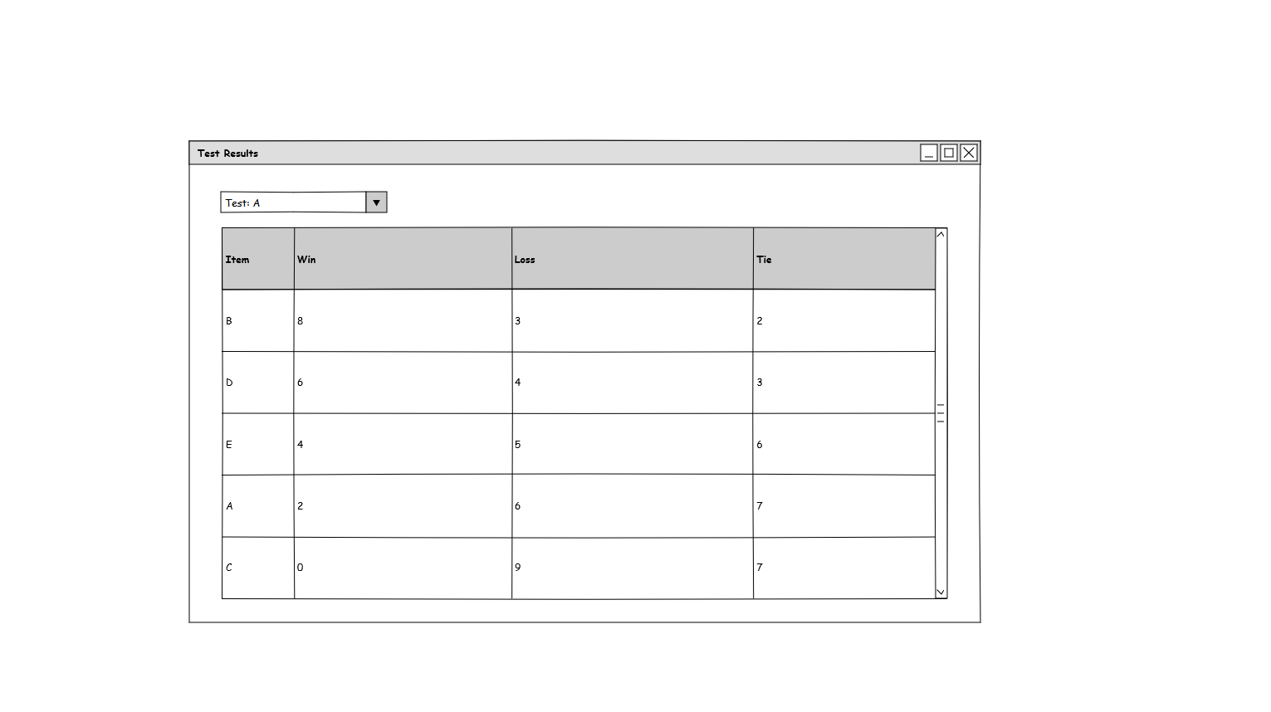

Figure

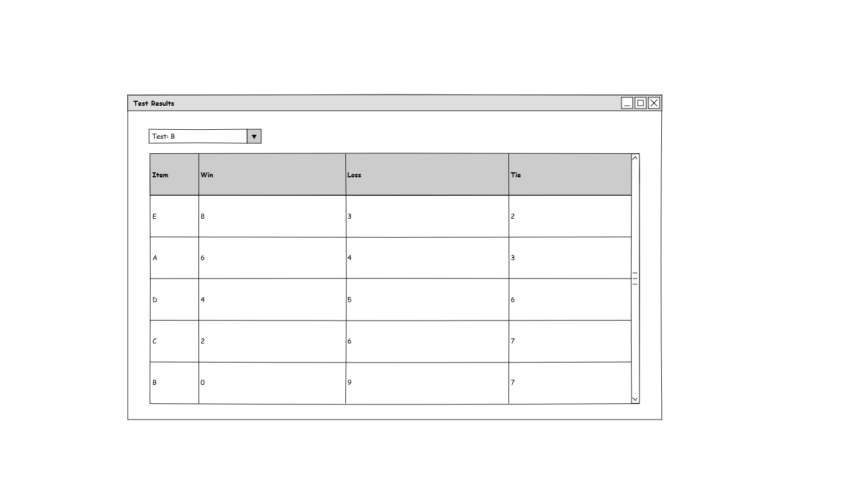

Figure 2